H.T No
Regulations:
A22

Sreenidhi Institute of Science and Technology
(An Autonomous Institution)
Code No:9K201 Date: 11-July-2025 (FN)

B.Tech I-Year II- Semester External Examination, July-2025 (Regular & Supplementary)
ENGINEERING MECHANICS (CIVIL)

Time: 3 Hours Max.Marks:60

Note: a) No additional answer sheets will be provided.
b) All sub-parts of a question must be answered at one place only, otherwise it will not be valued.
c) Missing data can be assumed suitably.
Bloom's Cognitive Levels of Learning (BCLL)

Remember | L1 | Apply | L3 | Evaluate | L5
Understand | L2 | Analyze | L4 | Create | L6

Part - A Max.Marks: 6x2=12

Answer all QUESTIONS, EACH QUESTION CARRIES 2 MARKS.

 |  | BCLL | CO(s) | Marks
1 | State Lami’s Theorem. | L1 | CO1 | [2M]
2 | List the laws of friction. | L1 | CO2 | [2M]
3 | Differentiate centroid and center of gravity. | L3 | CO 3 | [2M]
4 | Explain parallel axis theorem. | L2 | CO 4 | [2M]
5 | Define the terms Kinetics and kinematics. | L1 | CO 5 | [2M]
6 | State Work –energy principle. | L1 | CO 6 | [2M]

Part – B Max.Marks: 6x8=48
ANSWER ALL QUESTIONS. EACH QUESTION CARRIES 8 MARKS.

 |  | BCLL | CO(s) | Marks
7 | Solve for the reactions at L, M, N and S on the two cylinders shown in the figure given below. (Assume all the surfaces to be smooth).  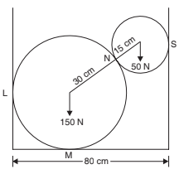 | L4 | CO 1 | [8M]
 | OR
8 | If the resultant force acting on the bracket is to be 750 N directed along the positive x axis, determine the magnitude of F and its direction ‘θ’.  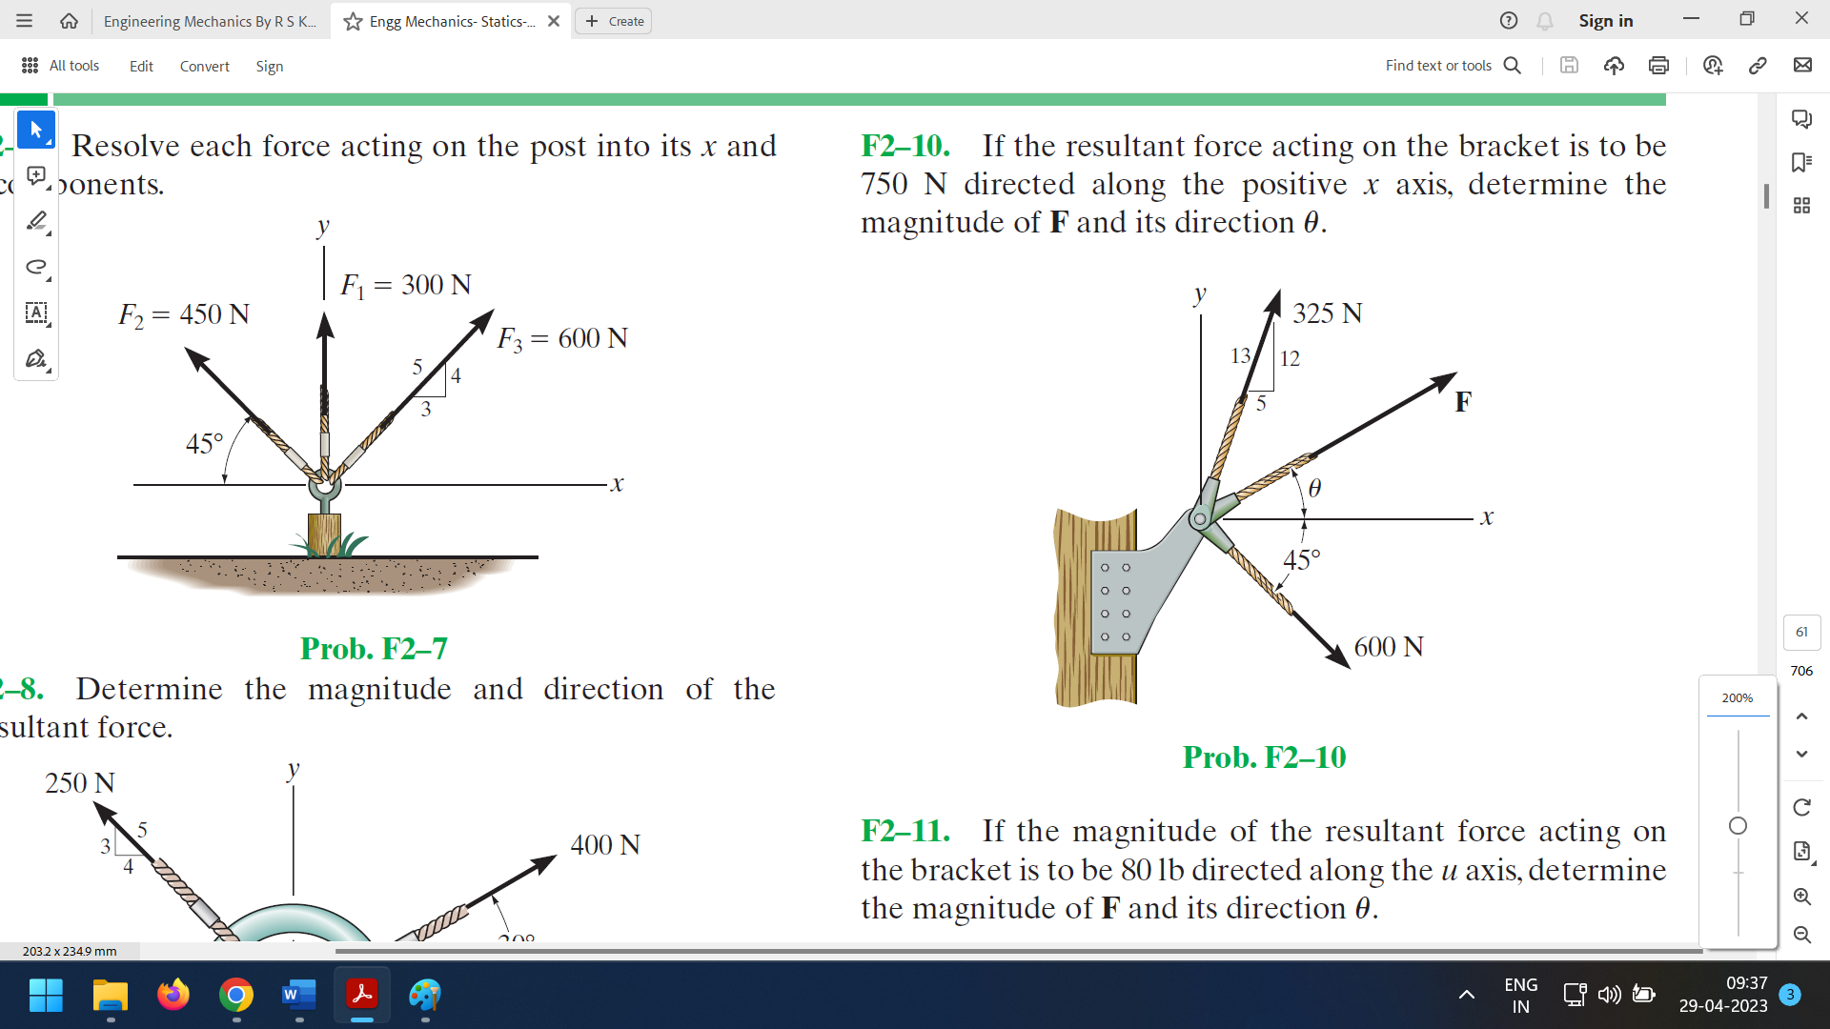 | L5 | CO 1 | [8M]
9 | A uniform ladder of 4 m length rests against a vertical wall with which it makes an angle of 45°. The coefficient of friction between the ladder and the wall is 0.4 and that between ladder and the floor is 0.5. If a man, whose weight is half of that of the ladder ascends it, how high will it be when the ladder slips? | L4 | CO 2 | [8M]
 | OR
10 | Find the value of ‘P’ for the Figure below so that the block just slides to move right side. Take µ = 0.30  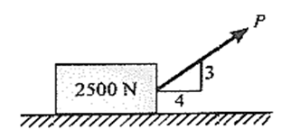 | L4 | CO 2 | [8M]
11 | Determine the center of gravity of the body shown in the figure below about point ‘D’.  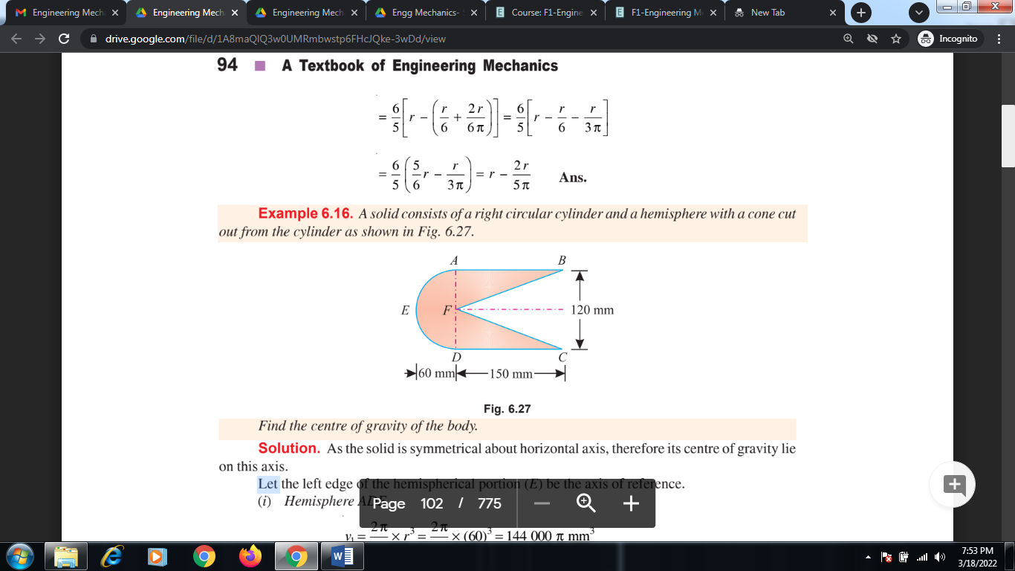 | L4 | CO 3 | [8M]
 | OR
12 | Locate the centroid for the shaded area shown below. Assume h=100mm, a=50mm.  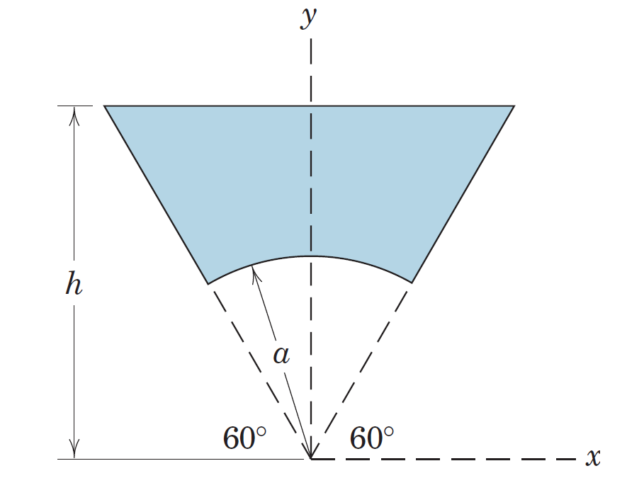 | L4 | CO 3 | [8M]
13 | Determine the Moment of Inertia for the T-section shown below about the centroidal X-axis.  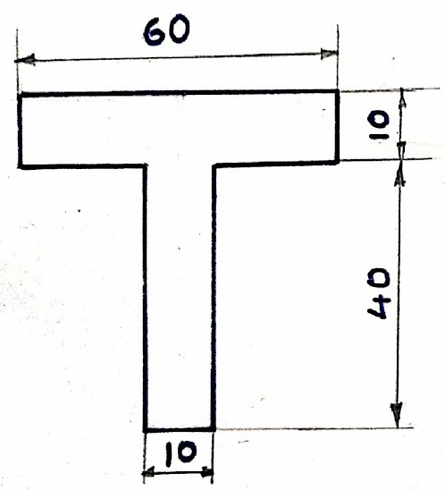 | L4 | CO 4 | [8M]
 | OR
14 | Determine the moment of inertia of the Z-section about the centroidal axis Xo & Yo.  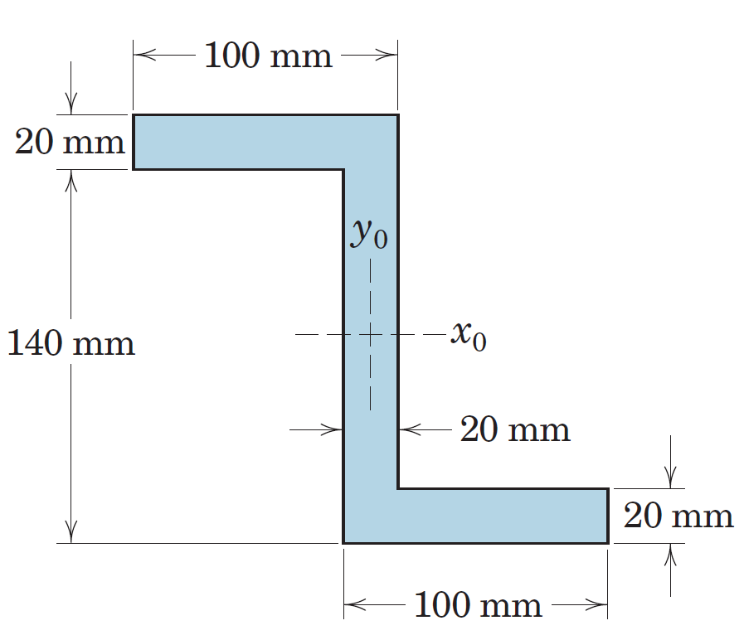 | L4 | CO 4 | [8M]
15 | A stone is dropped from the top of a tower. When it has travelled a distance of 10m, another stone is dropped from a point 38m below the top of the tower. If both the stones reach the ground at the same time, calculate  (i) The height of the tower and  (ii) The velocity of the stone when they reach the ground | L3 | CO 5 | [8M]
 | OR
16 | Two cars A and B travelling in the same direction get stopped at a traffic signal. When the signal turns green, car accelerates at 0.75 m/s². 1.75 seconds later, car B starts and accelerates at 1.1 m/s². Determine  - when and here B will overtake A and  - The speed of each car at that time. | L3 | CO 5 | [8M]
17 | A lift has an upward acceleration of 1.25m/s²:  (a) What pressure will a man weighing 500N exert on the floor of the lift?  (b) What pressure would be exerted if the lift had an acceleration of 1.25m/s² downwards?  (c) What upward acceleration would cause his weight to exert a pressure of 600N on the floor? | L3 | CO 6 | [8M]
 | OR
18 | Define general principles of dynamics and explain motion and types of motion. | L2 | CO 6 | [8M]
-- 00 -- 00 –

